What is a Dupuytren's contracture?
Dupuytren's contracture is a condition where firm painless lumps or nodules fixed to skin and deep fascia appear in the palm of hand. In some cases these nodules group to form cords. When the cord gradually contracts, it can prevent the finger straightening completely.

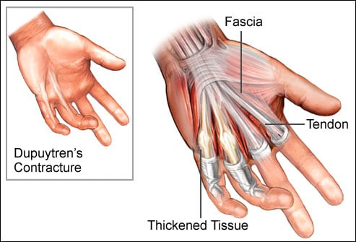

https://www.webmd.com/arthritis/ss/slideshow-treatment

How is it caused?
There is no single cause for Dupytren’s contracture.

You are more likely to develop a Duprutyens contracture if you are male, have a family history of the condition, if you have diabetes, if you smoke, if you drink alcohol or have high cholesterol.

It occasionally appear after injuries to wrist or hand and sometimes after surgeries to these areas.

What are the symptoms?
In the early stages:
- Pitting and thickening of the palm skin
- A lump or nodule in the palm most commonly in line with the ring or little finger. The nodule may feel tender and sore at first, but this discomfort eventually goes away.

In the later stages:
- The nodule contracts and extends to form cords. These inflexible cords cause the fingers to bend, or "curl," forward toward the palm and prevent them from straightening fully.
- Difficulty with tasks such as face washing, hair combing, and putting the hand in your pockets.

How is it diagnosed?
A Duputryens contracture is normally diagnosed based on you tell us and a physical examination. Being unable to lay your palm flat on a tabletop raises the suspicion of a Durptryen’s contracture.
What Can I do?
Unfortunately, there is no way to prevent the disease or stop it from coming back. However, you can minimise your risk by addressing lifestyle factors such as reducing smoking and alcohol intake and controlling diabetes.

What other options are there?
Surgery:
This is the main treatment offered for a Duputryen’s contracture and is generally considered for patients when there is shortening and contracture of the hand and function becomes more effected. Restoring movement at the knuckle joint can be achieved more easily than that at the smaller finger joints.

Patients must be aware that Dupuytren’s contracture can return to the same place on the hand or may reappear somewhere else with up to 40% of people have a recurrence following surgery. Recurrence is more likely (up to 70%) in younger male patients, if the original contracture was severe or affected both hands, or if there is a strong family history of the condition.

Recovery after surgery varies depending on amount of contracture. It can take a long time to recover full or partial function of the hand. After surgery you may be referred to Hand Therapy for ongoing advice.

