Essex Perinatal Mental Health Service
Is this referral (please see Severity Guide at end of form)
☐URGENT (please phone the team) | ☐ROUTINE

Area
☐South East Essex | ☐South West Essex
☐North East Essex | ☐Mid Essex
☐West Essex

Referrer details
Name:
Agency:
Contact Number:
Email Address:
Has the patient consented to the referral and being contacted by PNMHS ☐Yes ☐No
(this can be via text/ telephone or letter and it will be from withheld number)

Patient Details |  |  |  |  |  | Antenatal Referral
Name:  Preferred Name: |  |  |  |  |  | EDD:
DOB: |  |  |  |  |  | Gestation:
Contact no: |  |  |  |  |  | Gravida/Parity:
Address: |  |  |  |  |  | Any previous losses:
 |  |  |  |  |  | Community Midwife:
NHS No:  Ethnicity: |  |  |  |  |  | DOB (Baby):
Interpreter required?
Remedy/Mobius number: (If known) |  |  |  |  |  | Health Visitor:
GP Surgery: |  |  |  |  |  | Other agencies involved:
 | Reason for referral
 | ☐Tokophobia (fear of childbirth)
 | ☐Prescribing advice in pregnancy and breastfeeding (for valproate treat as urgent and phone in)
 | ☐Preconception counselling – for valproate please refer to local FRT/AAT
 | ☐Moderate – severe mental illness: |  |  | ☐Current |  |  | ☐Past |  | ☐Both
 | ☐Depression | ☐Anxiety |  | ☐PTSD |  |  | ☐OCD |  | ☐Personality disorder
 | ☐Bipolar affective disorder |  |  | ☐Schizophrenia/Psychosis
 | ☐Family / Personal history of Bipolar affective disorder or post-partum psychosis
 | ☐Other (please describe)

 | Risk: | ☐Self (self harm / suicide) |  |  |  |  | ☐Others |  |  |  | ☐Baby
 |  | ☐Vulnerability |  |  |  |  | ☐Self neglect |  |  |  | ☐Exploitation
 | Please describe in detail:
When Perinatal red flags are present please consider urgent referral /discussion with our team and CRHT
• Recent and significant mental state change/ sudden fluctuation and deterioration in mood
• New thoughts/acts of self harm or harm to others ( baby in particular)
• Estrangement from infant/ inadequacy as a mother
• Thoughts / acts of absconsion
• Previous history of suicide /self harm
 | Additional Risk Factors:
 | ☐Substance Misuse |  | ☐Current |  |  |  | ☐Past
 | Substance Details |  | Type: Click here to enter text. |  |  |  | Amount: Click here to enter text.
 | ☐Learning Disability |  | ☐<18 year old
 | ☐Social Situation |  | ☐Unemployed |  | ☐Financial difficulties |  |  |  |  |  | ☐homeless
 |  |  | ☐Isolated |  | ☐Communication issues
 | ☐Medical problems
 | ☐Other
Current treatment and support in place
Current Medication:
Primary Care Treatment prior to referral:
(For women with mild- moderate depression/anxiety first step treatment as per CG 192 should be tried ie first line medication and IAPT/enhanced HV support ( post-natal) or additional Children social care support if appropriate /other 3rd sector agencies)
Other agencies involved
Adult Community MHT: |  |  |  | ☐Care Coordinator |  |  |  |  |  | ☐Psychiatrist
Children Social Care: |  |  |  | ☐CIN Plan |  | ☐CP Plan
 |  |  |  | ☐Under assessment |  |  |  | ☐Unknown
Adult Social Care: |  |  |  | ☐MARAC |  | ☐MAPPA
Other: (ie Substance misuse, eating disorder, 3rd sector, etc)
Family / Friends Support:

Scores – Routine Questionnaires
EPDS Insert Score | GAD 7 Insert Score
PHQ 9 Insert Score | Other Insert Score + Specify Questionnaire

Severity Guidance
Please use this as a point of reference for urgent and moderate to severe referrals please phone in the office to discuss with our duty worker.
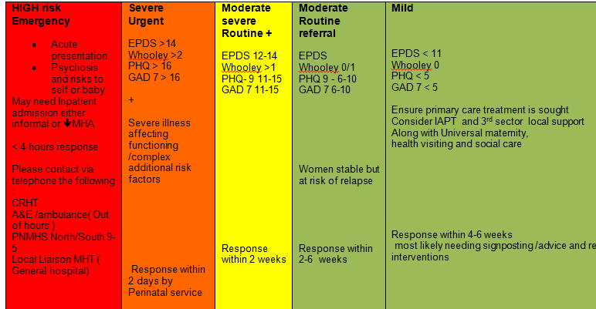

Area of referral/contact details
North Hub  Perinatalteam@nhs.net  Specialist MH Midwife (Mid Essex)  Amy Harrington  Mandy Ward  Tel: 01245 513251  Sue Calahan (NE )  01245315637 | NE – Colchester Hospital  WE Princess Alexandra hospital  Mid – Chelmsford
South Hub  Perinatalteam@nhs.net  Specialist MH Midwife  Vicky Stewart ( Basildon, Thurrock, Brentwood)  Frances Jory ( Southend , Castlepoint, Rochford)  01702538170 | Southend Hospital  Basildon Hospital

