Children’s Therapy Services

Patient Information
Learning to do buttons

 | Things to try
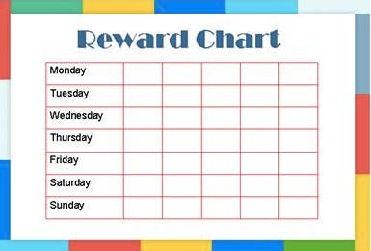 | General advice:  Practice whilst sitting on a chair.  Use a reward chart to help motivate your child.
Posting | Doing buttons is like posting the button in and out of the button hole.  It helps to get good at posting.  Post small objects into a slot such as a piggy bank.  Try things like plastic coins or buttons.  -Say the word ‘pinch’ when pinching the button.  -Say the word ‘post’ when  posting it through the slot.

Improving pincer grip  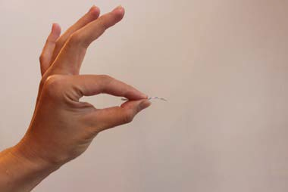  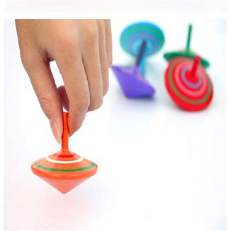  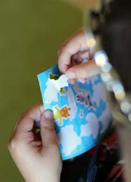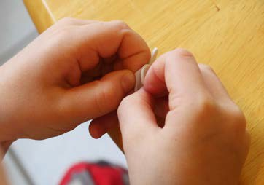 | Pincer grip: Using thumb and index finger to pick up small things.  You need a good pincer grip to do buttons  Activities that help your child to get a good pincer grip:  Examples:  - -Spinning tops  - Peeling stickers

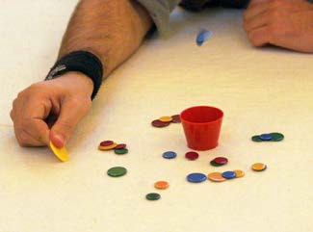  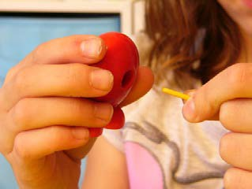  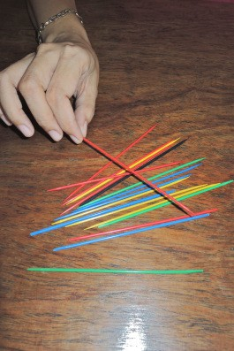 | - Tiddlywinks  - Stringing beads  - Pick-up sticks

Getting ready to do buttons  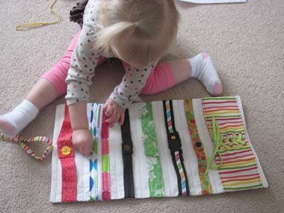  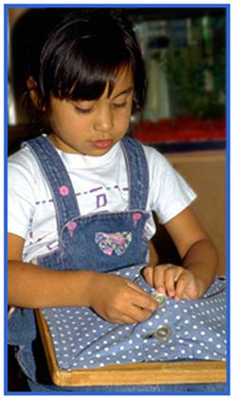  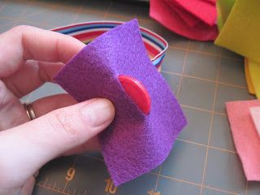 | Lay a piece of clothing with large, loose buttons in front of your child.  Start with unfastening the buttons.  Remind your child to:  - pinch the button then  - post it through the hole  When your child is good at unfastening buttons, they can practice fastening.  You can make this easier by doing the following  Step 1: You put the button in.  Step 2: Your child pulls the button through.

Playing with buttons  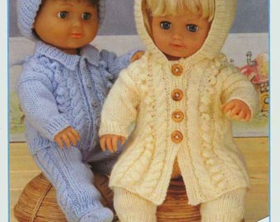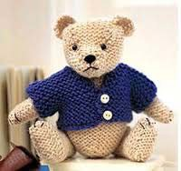 | Dress a doll or teddy bear to practice buttons.
Doing Buttons on clothes  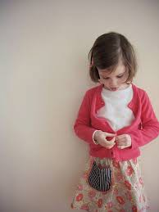 | When learning to do buttons on clothes make sure that  - Your child wears a coat or cardigan with large, loose buttons.  - Your child can see the buttons.  Practise unfastening the buttons first.  When your child can unfasten the buttons they can practise fastening.

Easy buttons  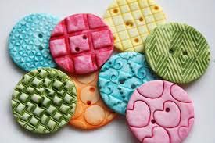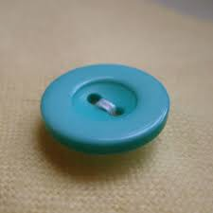  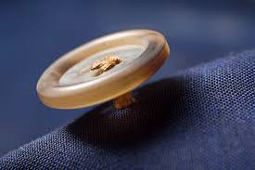 | The easiest buttons to grasp are:  - Flat  - Large  - Textured  - Sewn slightly above the surface  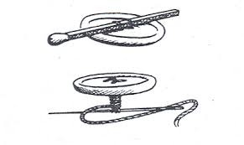  Make sure that the buttonholes are large enough.  This way the button can pass through easily.

Easy buttons  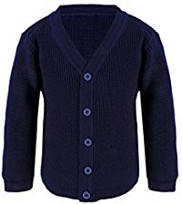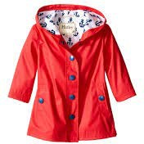 | If your child need to use buttons very often,  for example on coat or school shirt :  - change the buttons to larger ones.  Larger buttons are much easier to do up!
Getting good at buttons  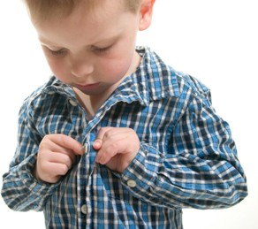 | Start to use smaller size buttons.  Keep using the words ‘pinch and post’ until your child can fasten the buttons themselves.

Contact details:
Children’s Occupational Therapy
E-mail: epunft.OTenquiries@nhs.net

