Children’s Therapy Services

Patient Information
Improving fine motor skills- general

What are fine motor skills?  Fine motor skills help you to use your hands well.  You need good fine motor skills for lots of things. | Examples:  - doing up buttons  - holding a pen  - using scissors
Improving Shoulder control  You need strong shoulders to use your hands well. | Things to try
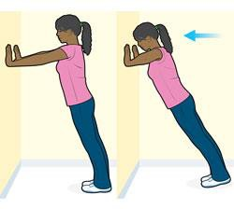 | Wall press ups Start position:  -Hands at shoulder level  -shoulder width apart  -keep back straight  - Bend your elbows and touch the wall with your nose.  - Push away again until your elbows are straight.

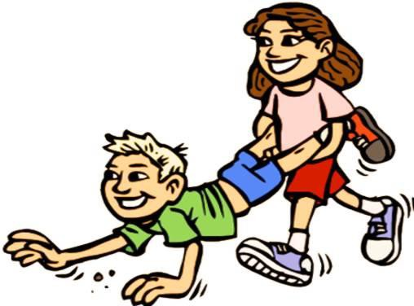 | Wheelbarrows You can do races or  Try how far you can go
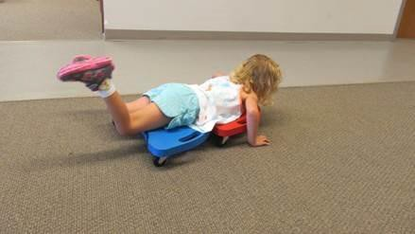 | Boarding  Push yourself along on a scooter board  or skateboard
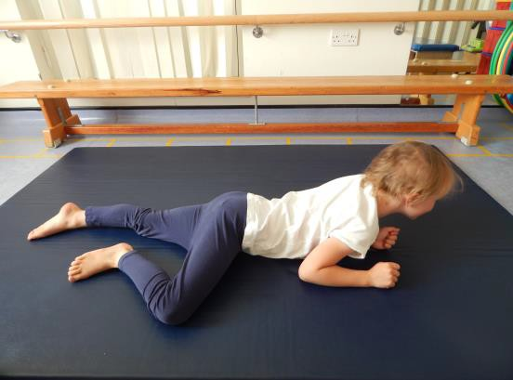 | Commando crawling Lie on your tummy.  Now move along the floor using forearms.
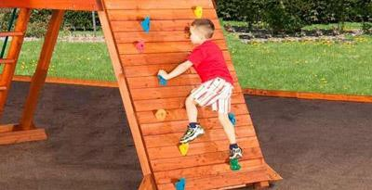 | Climbing frames and walls

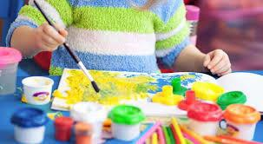  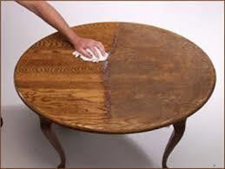  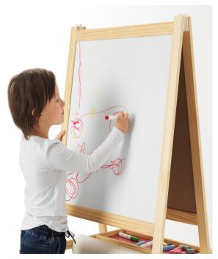 | Activities on a table Examples:  -painting  -wiping or polishing the table  -drawing large patterns on a chalkboard or whiteboard.
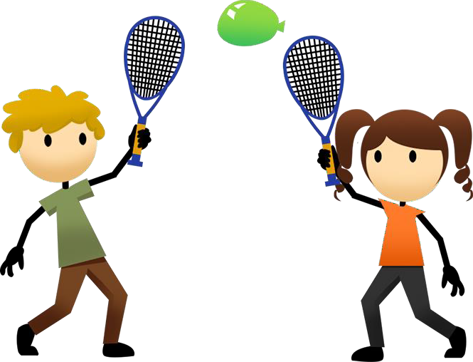 | Ball games  Play throwing and catching games. or  Racket games using a balloon  Try to keep the balloon in  the air. Keep your elbows straight.

Improving hand -strength  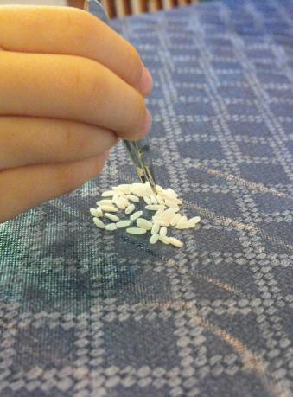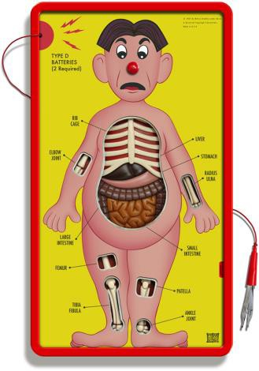  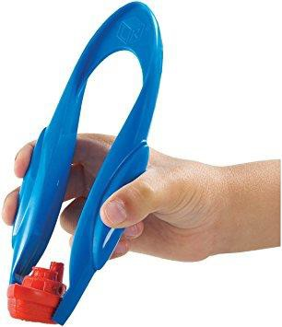 | Use tweezers to pick up things.  Try picking up  -rice  -raisins  - play games such as operation
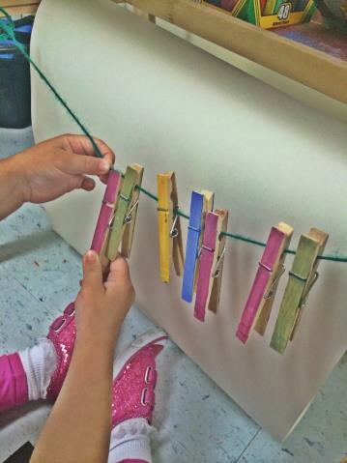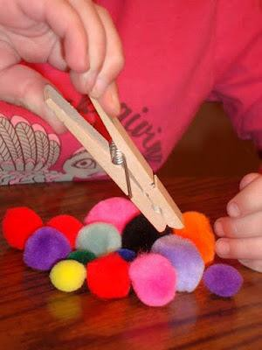 | Playing with pegs  Clip pegs onto a line Pick up pom poms with a peg.  Can you do this only using your thumb and pointer finger?

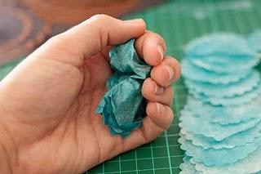  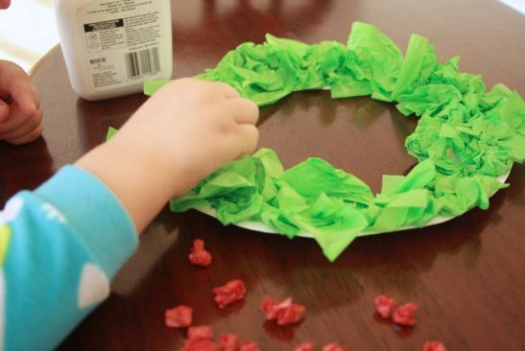  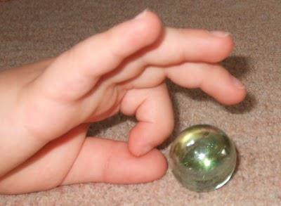 | Playing with paper  Tear tissue paper or material into small strips. Scrunch it up into small balls.  You can make a collage  You can also flick the paper balls  or  flick marbles
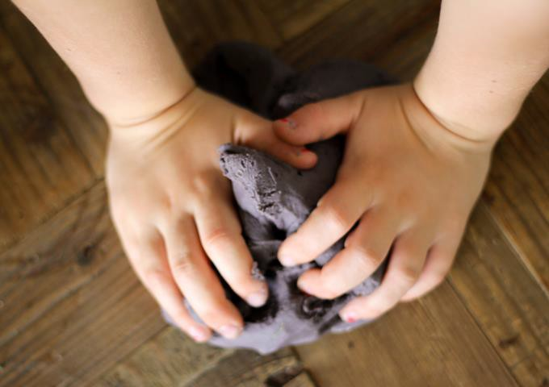 | Play with dough  -squeeze  -pull  -knead  Use real dough or Play-dough.

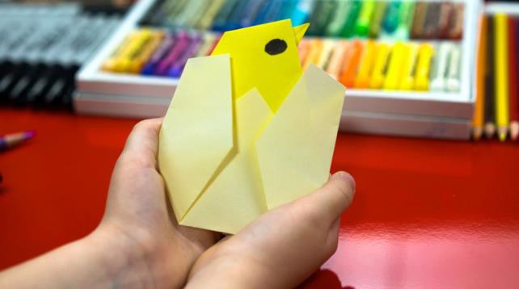 | Folding paper
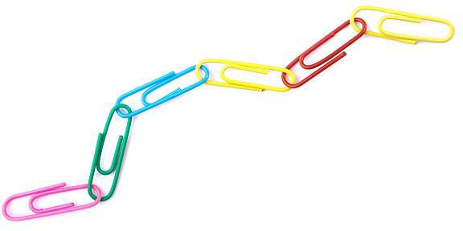 | Use paper clips to make a chain
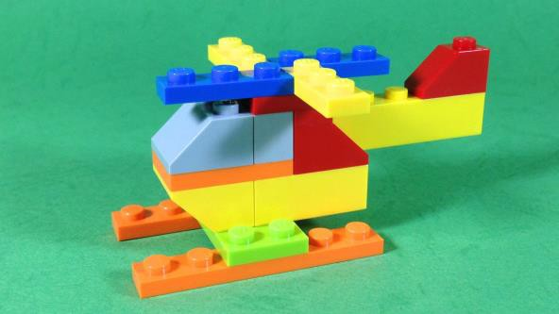  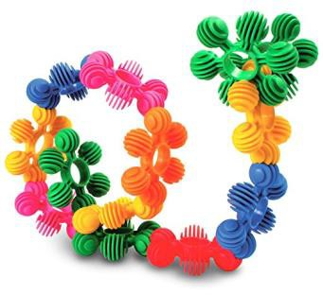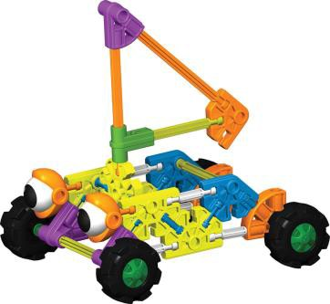 | Play with construction toys  that you need to push together and pull apart  Examples:  -LEGO  -Inter star rings  -K’NEX

