ESSEX PARTNERSHIP UNIVERSITY NHS FOUNDATION TRUST

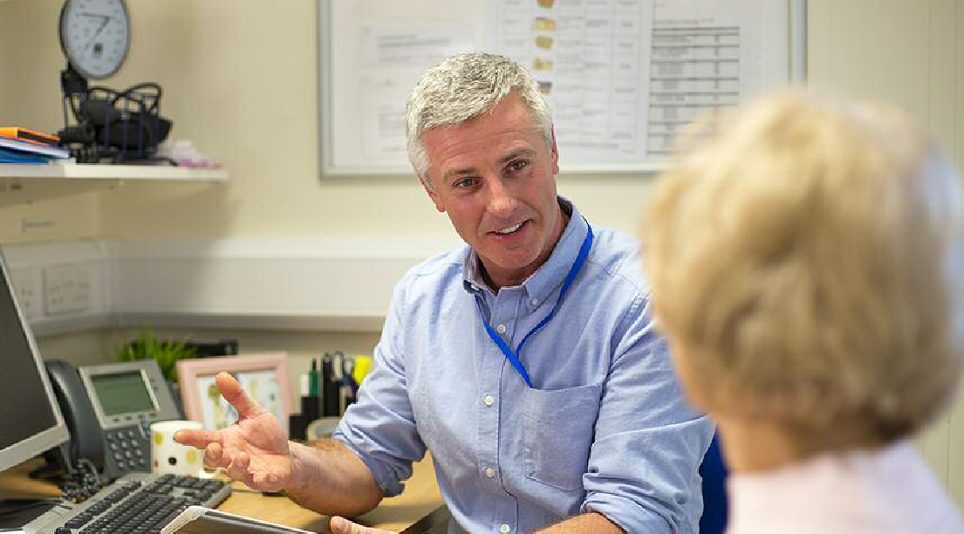

GENDER PAY GAP REPORT 2024

Background to the Trust

Essex Partnership University NHS Foundation Trust (EPUT) was formed on 1 April 2017 following the merger of North Essex Partnership University NHS Foundation Trust (NEP) and South Essex Partnership University NHS Foundation Trust (SEPT). EPUT provide community health, mental health and learning disability services for a large population of people throughout Bedfordshire, Essex, Suffolk and Luton. We employ approximately 6,800 staff excluding bank across multiple sites.
EPUT is committed to being an equal opportunities employer and to building equality, diversity and inclusion into everything that it does.
Gender pay gap reporting
Legislation requires organisations with 250 or more employees to report annually on their gender pay gap. NHS organisations are covered by the Equality Act 2010 (Specific Duties and Public Authorities) Regulations 2017, which came into effect on 31 March 2017. These regulations underpin the Public Sector Equality Duty, which requires organisations to publish their gender pay gap data annually, including mean and median gender pay gaps; mean and median gender bonus gaps; proportion of men and women receiving bonuses; and the proportions of male and female employees in each pay quartile.
Gender pay gap reporting demonstrates the difference in average pay between men and women in a workforce. If a workforce has a particularly high gender pay gap, this can indicate issues to deal address, and further analysis may help identify the cause of those issues.
It is important to stress that the gender pay gap is different to equal pay. Equal pay considers pay differences between men and women who carry out the same jobs, similar jobs or work of equal value. It is unlawful to pay people unequally on the grounds of their gender.
In June 2023, NHS England launched the EDI Improvement Plan which sets out targeted actions to address the prejudice and discrimination – direct and indirect – that exists through behaviour, policies, practices and cultures against certain groups and individuals across the NHS workforce. The independent review Mend the gap (2020) describes actions that the NHS should take to address the gender pay gaps in medicine. Many of its recommendations can also be applied to non-medical senior leaders. By 31 March 2024, organisations are required to analyse data to understand relationships between pay, sex, and race.
This report includes:
- data and analysis relating to the gender pay gap
- data and analysis relating to the race pay gap, based on pay grades
- an action plan to address the pay gap (see appendix).

Definitions and scope
The gender pay gap is defined as the difference between the mean or median hourly rate of pay that male and female colleagues receive. The mean pay gap is the difference between average hourly earnings of men and women. This is commonly known as the average and is calculated when you add up the wages of all employees and divide the figure by the number of employees.
The median pay gap is the difference between the midpoints in the ranges of hourly earnings of men and women. It takes all salaries in the sample, lines them up in order from lowest to highest, and picks the middle-most salary.
It is important to note that although this report includes the breakdown of pay grades by race, the scope is different to that of the Workforce Race Equality Standard (WRES). While the WRES is based on a

snapshot of one day (31 March), the data extracted for this report is based on the financial year (1 April – 31 March). Therefore, as it includes paid substantive assignments and bonuses within that period, the total number of staff in this report will be different to that in the WRES.
What is the gender bonus gap?
Within the gender pay gap regulations, ‘bonus pay’ means any remuneration that is the form of money relating to profit sharing, productivity, performance, incentive or commission.
It is clear within the regulations that bonus pay does not include ordinary pay, overtime pay and redundancy pay or termination payments.
For the purpose of gender pay reporting, ‘Clinical Excellence Awards’ payments are regarded as ‘bonus pay’. The Clinical Excellence Awards (CEA) scheme is intended to recognise and reward those consultants who perform ‘over and above’ the standard expected for their role. Awards are given for quality and excellence, acknowledging exceptional personal contributions towards the delivery of safe and high quality care to patients and to the continuous improvement of NHS services.
There are 12 Levels of award with monetary value. Levels 1-9 are awarded locally (employer-based awards) and Levels 10-12 (silver, gold and platinum hereafter) are awarded nationally in accordance with assessment criteria and application.
Consultants with an existing distinction award or discretionary points retain them, subject to existing review provisions, and are eligible to apply for awards under the new scheme in the normal way.
Accordingly, the legacy of the CEA scheme means that there will continue to be a gender pay gap because there are more male consultants than female consultants and the gender balance is only likely to improve over time (see above, and medical workforce and CEA breakdown below).
EPUT’s gender pay gap
The following gender pay gap report data is taken as the snapshot date of 31 March 2023.
1. | The mean gender pay gap for EPUT | 12.93%
2. | The median gender pay gap for EPUT | 7.31%
3. | The mean gender bonus* gap for EPUT | 56.01%
4. | The median gender bonus* gap for EPUT | 66.84%

* Please see comments later in this report explaining what constitutes a bonus.

Pay quartiles by gender
Quartile | Female Headcount | Male Headcount | Female  % | Male  % | Description
1  (lowest paid) | 1431.00 | 333.00 | 81.12% | 18.88% | Includes all employees whose standard hourly rate places them at or below the lower quartile
2 | 1362.00 | 403.00 | 77.17% | 22.83% | Includes all employees whose standard hourly rate places them above the lower quartile but at or below the median
3 | 1365.00 | 384.00 | 78.04% | 21.96% | Includes all employees whose standard hourly rate places them above the median but at or below the upper quartile
4  (highest paid) | 1291.00 | 489.00 | 72.53% | 27.47% | Includes all employees whose standard hourly rate places them above the upper quartile

What do we do to ensure equal pay?
As noted earlier in this report, it is important to stress that the gender pay gap is different to equal pay. Equal pay deals with the pay differences between men and women who carry out the same jobs, similar jobs or work of equal value. It is unlawful to pay people unequally because of their gender.
Legislation requires that men and women must receive equal pay for:
- the same or broadly similar work
- work rated as equivalent under a job evaluation scheme; or work of equal value.

We are committed to providing equal opportunities and equal treatment for all employees, regardless of sex, race, religion or belief, age, marriage or civil partnership, pregnancy/ maternity, sexual orientation, gender reassignment or disability. We pay employees equally for the same or equivalent work, regardless of their sex or race (or any other characteristic set out above).
We deliver equal pay through a number of means but primarily through adopting nationally agreed terms and conditions for our workforce:

National NHS Agenda for Change Terms and Conditions of Service (AfC)
AfC is negotiated nationally by the NHS Staff Council, led by NHS Employers. The national NHS Staff Council has overall responsibility for the AfC pay system and has representatives from both employers and trade unions. AfC provides the framework for pay arrangements which are in place at EPUT.
Typically, AfC terms and conditions apply to nursing, allied health professionals and administration and clerical staff, which are the majority of the workforce.
Where appropriate, locally agreed policies may supplement AfC arrangements, such as:
- family friendly policies
- evaluating job roles and pay grades as necessary to ensure a fair structure
- starting salaries policy.

Medical and dental staff are employed on national Terms and Conditions of Service (TCS) and pay arrangements
These pay arrangements are negotiated nationally on behalf of employers by NHS Employers with the NHS trade unions. These terms and conditions include all consultants, medical and dental staff and doctors and dentists in training
Very senior managers (VSMs), Chairs and non-executive directors (NEDs)
As an NHS Foundation Trust, EPUT is free to determine its own rates of pay for its VSMs, Chairs and NEDs. VSMs include chief executives, executive directors and other senior managers with board level responsibility who report directly to the chief executive.
* Negative figures in the column ‘gender pay gap by pay band’ indicate a gender pay gap in favour of females.
What is the data telling us?
The Gender Pay Gap (GPG) report looks at the average and median rates of two key indicators:
- The GPG hourly rate pay gap for EPUT is 12.93%, with males receiving an average of £20.61ph and females receiving £17.24ph. When comparing the median hourly rate this reduces to 7.31%. This is a reduction of 0.13% in the average percentage and the median has increased by 1.10% compared to 2022.

This result means that men on average are being paid 7.31% higher in the organisation than females.
- The GPG bonus pay gap for EPUT is 56.01%, with males receiving an average bonus pay of £9,449.11 compared to £4,157.12 for females. When comparing the median rate this increases to 66.84%. The average percentage has reduced by 3.49% and the median has reduced by 12.76% compared to 2022.

This result means that men are on average receiving a 66.64% increase on bonus pay than females within the organisation.
- A total of 2.07% of males received a bonus compared to 0.36% of females during the reporting period.

Bonus payments include elements of doctors pay, this staff group have a higher number of male employees, therefore increasing the bonus pay gap in comparison to other staff groups within the trust. The bonus pay elements are as follows:
    - Clinical Excellence Awards
    - Discretionary Points
    - Performance Related Pay.

Positively, over the past fifteen years there has been significant growth in the percentage of women in medical roles, which should see the gender bonus pay gap diminish with time:
- Female medical workforce – 17.7% growth from 31.2% in 2008 to 48.9% in 2023, although this is a reduction on the 2022 figure of 49.4%
- Female medical consultants – 13.0% growth from 22.7% in 2008 to 35.6% in 2023, although this is a reduction on the 2022 figure of 36.1%.

The current gender breakdown for our medical workforce is as follows.
Gender | Headcount | %
Female | 149 | 48.9%
Male | 156 | 51.1%
TOTAL | 305

Whilst there has been a growth in the female consultant medical workforce, the legacy of the CEA scheme means that there will continue to be a gender bonus pay gap because there are more male consultants than female consultants. The Trusts current medical consultant gender breakdown is detailed in the table below.
Year | Female Headcount | % of Total | Male Headcount | % of Total | % Difference between Female/Male
2021/2022 | 35 | 36.1% | 62 | 63.9% | 27.8%
2022/2023 | 36 | 35.6% | 65 | 64.4% | 28.8%

The chart below demonstrated the proportion of female and male consultants appointed by the Trust between 2017/18 to 2022/23:
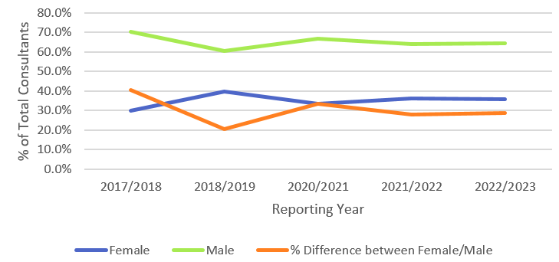
*Due to Covid-19, enforcement for reporting was suspended entirely for the 2019/20 reporting year.
The CEA allocation for 1st April 2022 – 31st March 2023 by gender identifies that more males were allocated awards compared to females.
Gender | Headcount awarded CEA | % | Total % of consultant workforce
Female | 10 | 22.7% | 9.9%
Male | 34 | 77.3% | 33.7%
TOTAL | 44 |  | 43.6%

EPUT’s staff profile by gender and race
The table below is a new breakdown for 2023 as outlined in the NHS EDI Improvement Plan (High Impact Action 3) and shows the breakdown of staff in scope by gender and race for the reporting period 1 April 2022 - 31st March 2023.
Gender | BME | % BME | White | % White | Not Stated | % Not Stated
Female | 1,413 | 25.93% | 3,888 | 71.34% | 149 | 2.73%
Male | 766 | 47.61% | 791 | 49.16% | 52 | 3.23%
TOTAL | 2,179 | 30.87% | 4,679 | 66.28% | 201 | 2.85%

The table below is a breakdown of pay grades by race:
AfC Pay Band | BME | % BME | White | % White | Not Stated | % Not Stated | Total in Pay band
Band 2 | 68 | 17.00% | 313 | 78.25% | 19 | 4.75% | 400
Band 3 | 857 | 41.60% | 1,170 | 56.80% | 33 | 1.60% | 2,060
Band 4 | 159 | 16.79% | 739 | 78.04% | 49 | 5.17% | 947
Band 5 | 342 | 40.14% | 481 | 56.46% | 29 | 3.40% | 852
Band 6 | 325 | 26.77% | 868 | 71.50% | 21 | 1.73% | 1,214
Band 7 | 155 | 20.05% | 601 | 77.75% | 17 | 2.20% | 773
Band 8 - Range A | 52 | 18.44% | 227 | 80.50% | 3 | 1.06% | 282
Band 8 - Range B | 29 | 20.86% | 109 | 78.42% | 1 | 0.72% | 139
Band 8 - Range C | 7 | 13.21% | 45 | 84.91% | 1 | 1.89% | 53
Band 8 - Range D | 7 | 19.44% | 28 | 77.78% | 1 | 2.78% | 36
Band 9 | 0 | 0.00% | 7 | 100.00% | 0 | 0.00% | 7
Board Director/VSM | 5 | 41.67% | 6 | 50.00% | 1 | 8.33% | 12
Medical | 170 | 66.15% | 62 | 24.12% | 25 | 9.73% | 257
Other | 3 | 11.11% | 23 | 85.19% | 1 | 3.70% | 27
Total | 2,179 | 30.87% | 4,679 | 66.28% | 201 | 2.85% | 7,059

The data in the table above demonstrates:
- A large proportion of the total BME workforce are paid at Band 3 (857)
- BME staff representation consistently decreases from Band 5 to Band 9
- There are no BME staff in a Band 9 role
- There is a greater proportion of BME medical staff compared with white medical staff (66.15% vs. 24.12%).

The table below shows the bonus payments broken down by gender and race as of 31st March 2023 for medical staff.
Gender | BME | % BME | White | % White | Not Stated | % Not Stated
Female | 13 | 56.52% | 10 | 43.48% | 0 | 0.00%
Male | 27 | 69.23% | 11 | 28.21% | 1 | 2.56%
TOTAL | 40 | 64.52% | 21 | 33.87% | 1 | 1.61%

The national picture
Note: due to reporting timeframes the national picture data is based on the previous reporting year 2022-2023.
The gender pay gap for workers is in favour of men for the majority of occupations; however, occupational crowding has an effect since those occupations with the smallest gender pay gap have almost equal employment shares between men and women.
It is also important to note that men and women have different personal and job characteristics, which ultimately impact their respective pay.
Across the UK, men earned on average 14.3% more than women in 2023, according to the Office of National Statistics, meaning that EPUT’s gender pay gap is below the national average.
Below is a comparison table of how EPUT’s gender pay gap sits in comparison to local neighbouring NHS organisations on the gov.uk website.

Organisation | Mean hourly rate 2022/23 | Median hourly rate 2022/23
Hertfordshire Partnership University NHS Foundation Trust (HPFT) | 8.9% lower than men’s | -0.3% lower than men’s
East London NHS Foundation Trust (ELFT) | 11% lower than men’s | 4.2% lower than men’s
EPUT | 13.1% lower than men’s | 6.2% lower than men’s
Norfolk And Suffolk NHS Foundation Trust | 14.4% lower than men’s | 7.7% lower than men’s
North East London NHS Foundation Trust (NELFT) | 15.5% lower than men’s | 11% lower than men’s
Mid and South Essex NHS Foundation Trust (MSEFT) | 27.4% lower than men’s | 13.8% lower than men’s
The Princess Alexandra Hospital NHS Trust | 24% lower than men’s | 16% lower than men’s
PROVIDE | 20.8% lower than men’s | 20.6% lower than men’s

Sample comparison data with neighbouring Trusts tells us:
- EPUT is performing well in comparison with neighbouring providers
- EPUT is a top performing NHS Provider in Mid & South Essex ICS (EPUT, MSEFT, NELFT, Provide).

As part of our action plan, we will be reaching out to HPFT and ELFT to share best practice and to learn what steps they have taken to reduce their gender pay gap.

EPUT’s progress
On comparison to EPUT’s gender pay gap for the year 2017, we have seen a reduction of 3.9% over the six years to 2023.
Following the year-on-year reductions in the mean gender pay gap between 2017 and 2021 we did see an increase to 13% in 2022. However, 2023 has seen a small reduction to 12.93%. A full comparison can be found within the table below:
 |  | 2017 | 2018 | 2019 | 2020 | 2021 | 2022 | 2023
1. | The mean gender pay gap for EPUT | 16.9% | 15.9% | 15.9% | 14.3% | 11.9% | 13% | 12.93%
2. | The median gender  pay gap for EPUT | 7.5% | 7.4% | 8.9% | 8.1% | 6.5% | 6.2% | 7.31%
3. | The mean gender bonus gap for EPUT | 34.4% | 31.2% | 25.2% | 33.6% | 47% | 59.5% | 56.01%
4. | The median gender  bonus* gap for EPUT | 50.3% | 51.7% | 45% | 30.8% | 75% | 79.6% | 66.84%

When comparing EPUT’s gender pay gap nationally, EPUT is below the national average of 14.9%.

The Trust recognises that it has further work to do in positively impacting the gender pay gap position, particularly amongst the medical workforce and application for CEA awards. The Gender Equality Network will drive improvements to the gender and race pay gap as well as broader gender equality within the Trust. Further details can be found in the attached appendix.

Lisa Fricker
Workforce/ESR and Payroll Manager

Lorraine Hammond
Director of Employee Experience

On behalf of:
Marcus Riddell
Interim Chief People Officer

March 2024

Essex Partnership University NHS Foundation Trust

Trust Head Office
The Lodge
Lodge Approach
Runwell
Wickford
Essex SS11 7XX

Tel: 0300 123 0808

