

**Application Form for Ingrowing Toenail surgery**

EPUT Podiatry Service needs to ensure it provides patients with the right service at the right time. Please help us to do this by **completing all sections of this form** so that your treatment is not delayed.

In line with local service guidelines, referrals to EPUT for ingrowing toenails will only be accepted for patients with moderate to severe symptoms where other treatment has been tried and failed.

**\*An ingrown toenail is defined as a nail ‘…which pierces the flesh’**.

A nail that is curling (involuted or convoluted) into the flesh, but isn’t actually piercing the skin, isn’t a true in-growing toenail.

Moderate-Severe Symptoms include:

• Increased pain and inflammation of the toe

• Foul smelling discharge

• Bleeding

• Recurrent infection

• Severe and disabling pain

• Substantial redness and inflammation

• Severe infection.

Please see below for example images of how an in-growing toenail may present, and what is not an ingrowing toenail. If you are unsure if you have an ingrowing toenail, please seek advice from your healthcare practitioner.

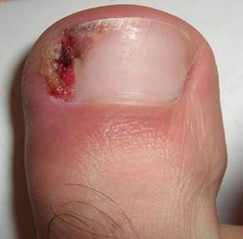

**True ingrowing toenail**

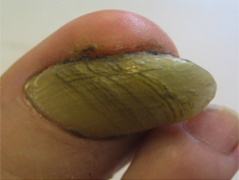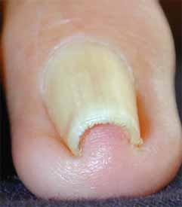 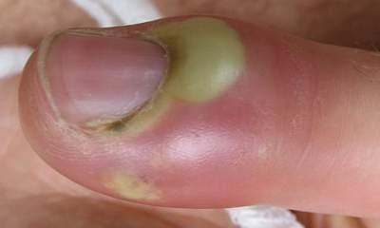

Swelling / redness at the base of the nail

Thickened nail

Curved nail

|  |  |
| --- | --- |
| Date of Referral: | NHS Number: |
|  | |
| **Patient Details** | |
| Forename: | Surname: |
| Address and Postcode: | |
| Date of Birth: | Gender: |
| Home Telephone: | Mobile Telephone: |
| Email address: | |

|  |  |  |  |  |  |
| --- | --- | --- | --- | --- | --- |
| **GP Details** | | | | | |
| Registered GP: | Telephone: | | | | |
| GP Practice: | Fax: | | | | |
| Have you received NHS Podiatry/Chiropody previously? | |  | Yes |  | No |
| Have you seen any other health professional regarding the problem you are seeking treatment for? | |  |  |  |  |
| If yes, when: | and where: | | | | |
| **\*\*\* Please supply an image of the toe/toenail that requires surgery \*\*\*** | | | | | |
| Do you meet the criteria below? Yes/No  If yes please tick as appropriate  The nail is piercing the flesh  Increased pain and redness of the toe  Pus  Bleeding  Recurrent or severe Infection  Severe and disabling pain  Photo attached | | | | | |
| How long has this problem been there and what measures have you already tried? | | | | | |
| Are you happy to have the procedure undertaken under a local anaesthetic? Yes/No | | | | | |

**Are you pregnant? Yes No**

|  |  |  |  |  |  |
| --- | --- | --- | --- | --- | --- |
| **Medical History** | | | | | |
|  | Allergies |  | Diabetes |  | Kidney Disease |
|  | Rheumatoid Arthritis |  | Poor Circulation |  | Registered Blind |
|  | Heart/Stroke |  | Neurological Disorder |  | Active Cancer |
|  | Hepatitis |  | Other | Nil | |
| If yes please give details- | | | | | |

**Medication**: Please attach a list.

**Patient equality and diversity information**

Please complete to help us ensure that the services we provide are fair, equal and inclusive.

|  |  |  |  |  |
| --- | --- | --- | --- | --- |
| **□** British or Mixed British | □ Irish | □ Other White Background | □ Other Mixed Background | □ Other Black Background |
| □ Other Asian Background | □ Other Ethnic Category |  |  |  |

|  |  |
| --- | --- |
| Main spoken language |  |

|  |  |  |  |  |  |
| --- | --- | --- | --- | --- | --- |
| **Disabilities (please indicate relevance to this referral)** | | | | | |
|  | Learning disability |  | Physical impairment |  | Sensory impairment |
|  | Mental Health condition |  | Longstanding illness |  | Other |
| Additional Information: | | | | | |

|  |  |  |  |  |
| --- | --- | --- | --- | --- |
| How would you like to have confirmation of receipt of referral?  **(please give details)** | □ Letter | □ Telephone | □ Text/Mobile | □ Email |

Do you give permission for EPUT Podiatry Services to share your care? This means your records will be shared with your GP and/or other departments involved in your health care.

**Yes** □ **No**  □

Patient’s Signature ___________________________ Date ________________

**Return completed forms to:**

EPUT Podiatry Services

Ashingdon House

Rochford Hospital

Union Lane

Rochford

Essex SS4 1RB

**E-mail Address:** epunft.southeastpodiatry@nhs.net