Children’s Therapy Services

Patient Information

Learning to do zips

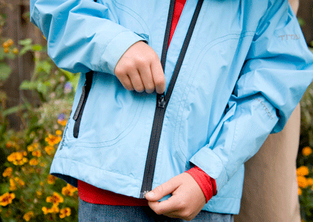 | Adult puts the zip on the track  Step 1- Child unzips the jacket Step 2 -Child moves the zip up
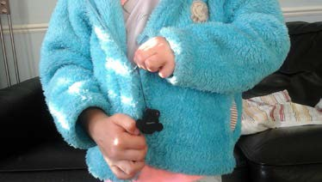 | Put the zip together for the child The child uses one hand to hold the bottom of the jacket.  The other hand to pull the zipper up.

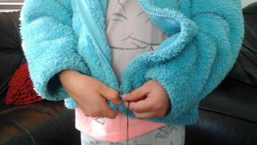 | Show the child how to align the zip before pulling up.
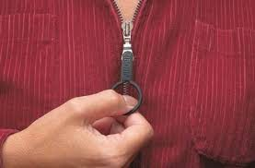  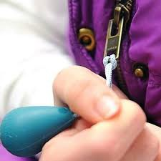 | To make it easier use  - a key-ring on the zipper  or  - a ribbon on the zipper

Contact details:
Children’s Occupational Therapy
E-mail: epunft.OTenquiries@nhs.net

