**Essex Perinatal Mental Health Service**

|  |  |
| --- | --- |
| **Is this referral (please see Severity Guide at end of form)** | |
| URGENT (please phone the team) | ROUTINE |
|  |  |

|  |  |
| --- | --- |
| **Area** | |
| South East Essex | South West Essex |
| North East Essex | Mid Essex |
| West Essex |  |

|  |  |
| --- | --- |
| **Referrer details** | |
| Name: |  |
| Agency: |  |
| Contact Number: |  |
| Email Address: |  |
|  | |
| **Has the patient consented to the referral and being contacted by PNMHS** Yes No | |
| (this can be via text/ telephone or letter and it will be from withheld number please advise client at time of doing referral ) | |

|  |  |  |  |  |  |  |  |  |  |
| --- | --- | --- | --- | --- | --- | --- | --- | --- | --- |
| **Patient Details** | | | | |  | **Antenatal Referral** | | | |
|  | | |  | |  |  | |  | |
| Name:  Preferred Name: | | |  | |  | EDD: | |  | |
|  | |
| DOB: | | |  | |  | Gestation: | |  | |
| Contact no:  PLEASE ENSURE CORRECT NUMBER | | |  | |  | Gravida/Parity: | |  | |
| Address: | | |  | |  | Any previous losses: | |  | |
|  | | |  | |  | Community Midwife: | |  | |
|  | | |  | |  |  | |  | |
| NHS No:  Ethnicity: | | |  | |  | DOB (Baby): | |  | |
| Interpreter required? | | |  | |  |  | |  | |
| Remedy/Mobius number: *(If known)* | | |  | |  | Health Visitor: | |  | |
| **GP Surgery:** | | |  | |  | Other agencies involved: | |  | |
|  | | |  | |  |  | |  | |
| **Reason for referral** | | | | | | | | |
| Tokophobia (fear of childbirth) | | | | | | | | |
| Prescribing advice in pregnancy and breastfeeding (for valproate treat as urgent and phone in) | | | | | | | | |
| Preconception counselling – *for valproate please refer to local FRT/AAT* | | | | | | | | |
| Moderate – severe mental illness: | | | Current | | | Past | | Both |
|  |  | |  | | |  | |  |
| Depression | Anxiety | | PTSD | | | OCD | | Personality disorder |
| Bipolar affective disorder | | | Schizophrenia/Psychosis | | | | |
|  | | | | | | | | |
| Family / Personal history of Bipolar affective disorder or post-partum psychosis | | | | | | | | |
| Other (please describe) | | | | | | | | |

**When Perinatal red flags are present please consider urgent referral /discussion with our team and CRHT – 01375 364632 (For Professionals Only!)**

• Recent and significant mental state change/ sudden fluctuation and deterioration in mood

• New thoughts/acts of self-harm or harm to others (baby in particular)

• Estrangement from infant/ inadequacy as a mother

• Thoughts / acts of absconsion

• Previous history of suicide /self-harm

|  |  |  |  |  |  |  |  |  |  |  |
| --- | --- | --- | --- | --- | --- | --- | --- | --- | --- | --- |
| **Risk:** | Self (self harm / suicide) | | | | | Others | | | | Baby |
|  | Vulnerability | | | | | Self neglect | | | | Exploitation |
| Please describe in detail: | | | | | | | | | | |
| **Additional Risk Factors:** | | | | | | | | | | |
| **Substance Misuse** | | Current | | | | Past | | | |  |
| *Substance Details* | | *Type:* Click here to enter text. | | | | *Amount:* Click here to enter text. | | | |  |
| **Learning Disability** | | <18 year old | | | | | | | | |
| **Social Situation** | | Unemployed | | Financial difficulties | | | | | | homeless |
|  | | Isolated | | Communication issues | | | | | | |
| Medical-physical health or obstetric problems (please list if pregnancy is high risk and why) | |  | | | | | | | | |
| Other | |  | | | | | | | | |
| **Current treatment and support in place** | | | | | | | | | | | | |
| Current Medication: | | | | |  | | | | | | | |
| Primary Care Treatment prior to referral: | | | | |  | | | | | | | |
| ***(For women with mild- moderate depression/anxiety first step treatment as per CG 192 should be tried ie first line medication and IAPT/enhanced HV support ( post-natal) or additional Children social care support if appropriate /other 3rd sector agencies)*** | | | | |
|  | | | | |  | | | | | | | |
| **Other agencies involved** | | | | | | | | | | | | |
| Adult Community MHT: | | | | Care Coordinator | | | | | | Psychiatrist | | |
| Children Social Care: | | | | CIN Plan | | CP Plan | | | |  | | |
|  | | | | Under assessment | | | | Unknown | | | | |
| Adult Social Care: | | | | MARAC | | MAPPA | | |  | | | |
| Other: (ie Substance misuse, eating disorder, 3rd sector, etc) | | | |  | | | | | | | | |
| Family / Friends Support: | | | |  | | | | | | | | |

|  |  |
| --- | --- |
| **Scores – Routine Questionnaires** | |
| **EPDS** *Insert Score* | **GAD 7** *Insert Score* |
| **PHQ 9** *Insert Score* | **Other** *Insert Score + Specify Questionnaire* |

**Severity Guidance**

Please use this as a point of reference for urgent and moderate to severe referrals please phone in the office to discuss with our duty worker.

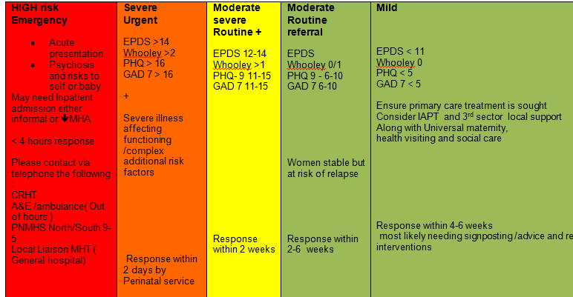

**Area of referral/maternity contact details-If you wish to discuss your referral with the perinatal Mental team directly, please call 01245 315637 and ask to speak to the North or south duty worker.**

If the patient is under midwifery remit, pregnancy and up to 28 days postnatal, please contact the perinatal midwife as below (please note that the perinatal MH team work closely with Midwifery but the perinatal midwives do not work under the perinatal team).

|  |  |
| --- | --- |
| **North Hub**  [Epunft.perinatalteam@nhs.net](mailto:Epunft.perinatalteam@nhs.net)  Specialist MH Midwife (Mid Essex)  Amy Harrington  Mandy Ward  *Tel: 01245 513251*  Specialist MH Midwife (North West Essex)  *Sarah Line - 01279 978246 ext 8246*  Specialist MH Midwife (North East Essex)  Kerri Nicoll - 01206742124 | NE Hub – Colchester Hospital  NW Hub -Princess Alexandra hospital  Mid Hub – Chelmsford |
| **South Hub**  [Perinatalteam@nhs.net](mailto:Perinatalteam@nhs.net)  Specialist MH Midwife (South West Essex)  Vicky Stewart – Team Lead - 07824 802670  Dolly Lamkin – Midwife - 07500 983820  (Basildon, Thurrock, Brentwood)  Specialist MH Midwife (South East Essex)  Frances Jory ( Southend , Castlepoint, Rochford)  01702538170 | SE Hub - Southend Hospital  SW Hub - Basildon Hospital |