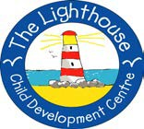
Children’s Therapy Services

Patient Information
Improving spatial awareness

Spatial awareness | Spatial awareness is understanding  -where you are in a space  -how far away other things and people are
Where is what?  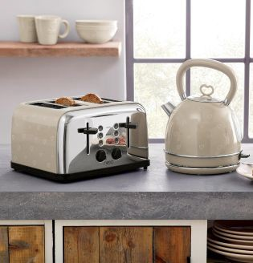 | Discuss the location of objects.  Example:  The Kettle is  in the kitchen  on top of the counter  next to the toaster
Toy detective  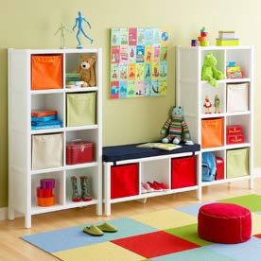 | Hide a toy in your child’s bedroom.  Give instructions where to find it.

Talking about pictures or scenery  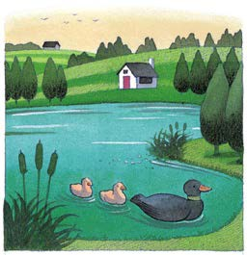 | Look at a picture. Talk about  -what is closer?  -what is further away?
Action games  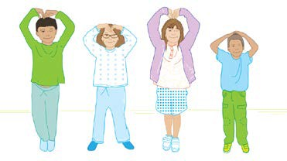 | Play a game of  - Simon says  or  - I robot
Building  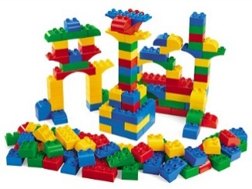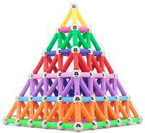  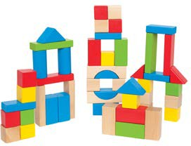 | Make 3 dimensional shapes or buildings.

Making a model  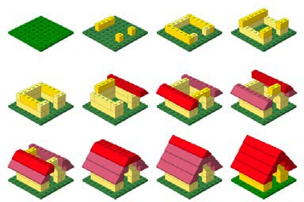 | Use instructions to make a model.
Obstacle courses  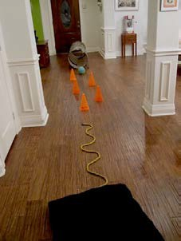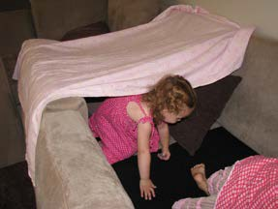  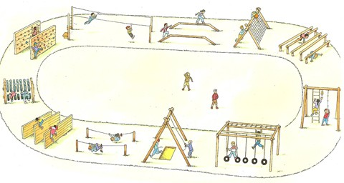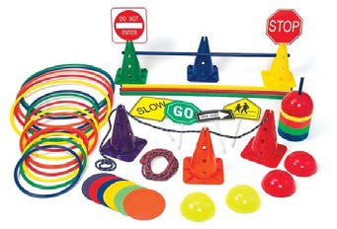 | Make obstacle courses at home.  Try obstacle courses in a park.  You can use different things to make an obstacle course.

Puzzles | Make jig-saw puzzles.
Throwing games:  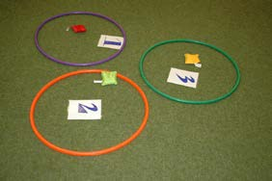  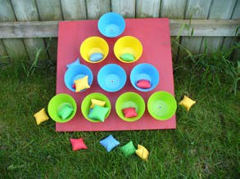  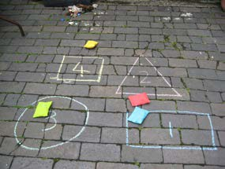  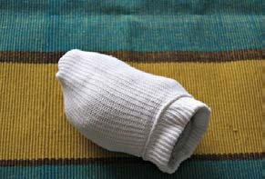 | Throw things at a target. Examples:  Bean bags in a hoop  Bean bags in buckets  Bean bags in shapes  If you do not have bean bags, you can use rolled up socks

Marbles  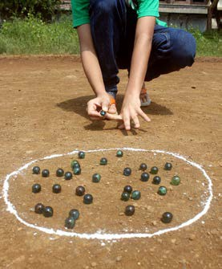 | Roll marbles into a circle.
Skittles  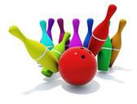 | Knocking over skittles.

Contact details:
Children’s Occupational Therapy
E-mail: epunft.OTenquiries@nhs.net

