Children’s Therapy Services

Patient Information
Learning to get dressed- first steps

Having fun with clothes | Things to try
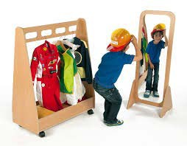 | Dressing up games in front of a mirror.
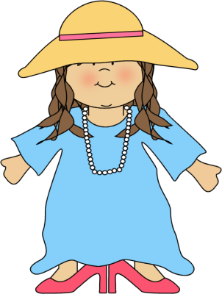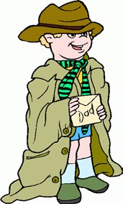 | Dress your child up in really big clothes and hats.  Can your child take the clothes off?
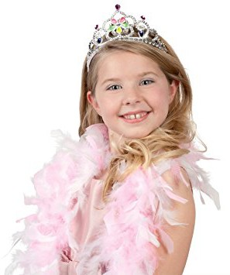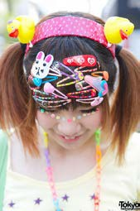 | Put on  - Beads  - Bracelets  - Hats tiaras  - Hairclips  Now take them off again.

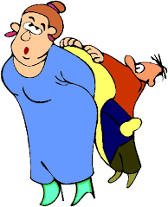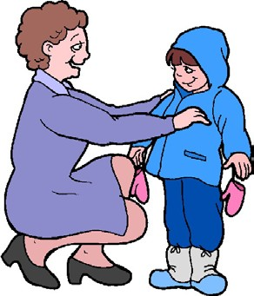 | Dress up Mummy or Daddy.  Talk about what the child needs to do.  For example:  -‘First you put the t-shirt over Mummy’s head.’  -‘Now we lift up her arm to put it in the sleeve.’  -‘Is the hat the right way  round?’
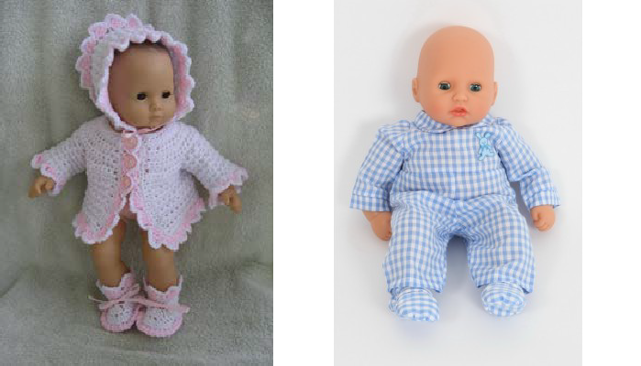 | Dress up a dolly or teddy. Talk about what the child needs to do.
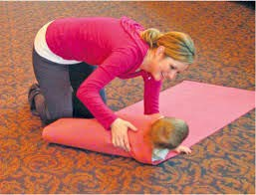 | Play going to bed:  -Wrap your child in a big sheet.  -Pretend to go to sleep.  -Can your child get out without help?

Knowing your body | For dressing you really need to know your body parts!
Action songs:  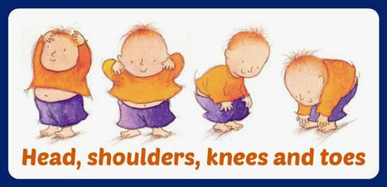  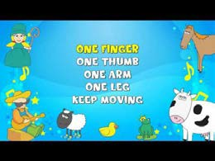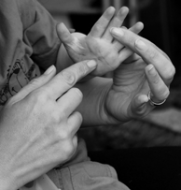 | Sing action songs with body parts.  Examples:  -‘Head shoulders knees and toes’  -‘One finger one thumb’  -‘This is the way we wash our face’  -‘Round and round the garden’  -‘This little piggy’
Parachute games :  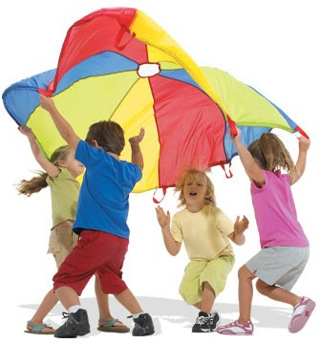 | Try going under the parachute  -Now come out the other side

Hiding a toy:  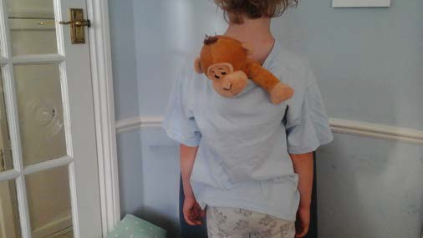  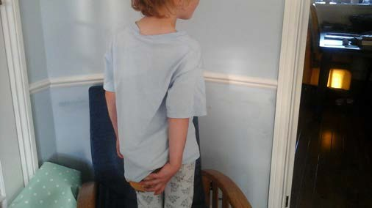 | Put a soft ball or toy under your child’s clothes.  -Try in front first  -Try under clothes at the back  -Can your child take the ball/ toy out?
Playing with pegs:  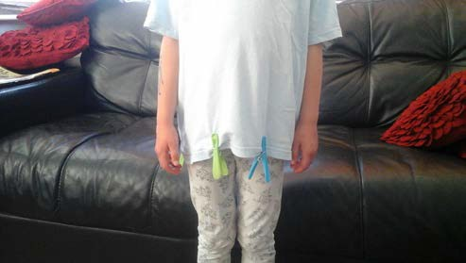 | Put pegs on your child’s clothes.  Can they take them off?

Hoola-hoop games:  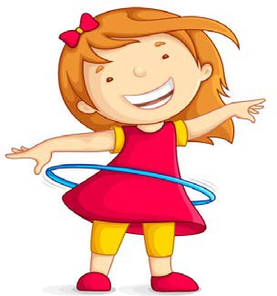 | -Put a hoola-hoop over your head  -Climb through the hoop  -Step into a hoola-hoop  - Now move it over your head
Rubber ring games :  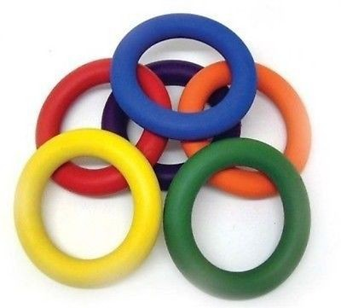 | -Move a rubber ring over your arm  -Now take it off  -Move a rubber ring over your leg  -Now take it off  -Try putting lots of rings on and off!

Contact details:
Children’s Occupational Therapy
E-mail: epunft.OTenquiries@nhs.net

