What is plantar fascia related pain?

Plantar fascia related pain (also known as ‘plantar fasciitis, plantar fasciopathy or ‘chronic heel pain’) is one of the most common causes of heel pain affecting 10-15% of the population. The Plantar Fascia is a sheet of broad band fibrous tissue that runs along the bottom of the foot. This tissue connects the heel to the base of the toes.

Under normal circumstances the plantar fascia supports the arch of the foot and acts as a shock absorbing ‘bow string’ within the arch of the foot. Sometimes the plantar fascia can become painful if excess stress is placed through it such as through injury/ trauma, an unaccustomed increase in activity levels or through degenerative changes.

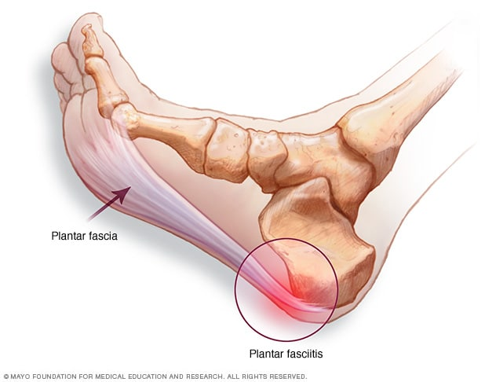

https://www.mayoclinic.org/diseases-conditions/plantar-fasciitis/symptoms-causes/syc-20354846

**How is it caused?**

Occasionally plantar fascia related pain may occur suddenly such as following trauma to the foot. However more commonly there is no known cause and the symptoms develop gradually over time. The condition is common in both active people as well as those with a less active lifestyle.

Factors which may predispose you to develop the condition include:

* Being over the age of 40
* Being overweight (having an increased BMI)
* Altered biomechanics e.g. people with ‘flat feet’ or high arches or those having tight calf muscles may be more at risk
* Physical activity overload e.g. advancing too quickly in a new sport or activity. Also occupations that require excessive standing and/or walking especially on hard surfaces can contribute.
* Footwear- lack of supportive shoes that provide cushioning/shock absorption can overload the plantar fascia.
* Other factors – A history of inflammatory arthritis and diabetes can also predispose you to develop the condition.

**Signs and symptoms**

Pain usually starts gradually without any injury to the area. It is often felt on the underside of your heel on the sole of your foot approximately 4cm forward from the back of your heel. It may be very tender to touch. Pain is often a deep, aching sensation but can also feel sharp. Pain is commonly more pronounced first thing in the morning when you put your foot to the floor or standing up after a period of sitting still. Typically pain eases with activity although may become more painful towards the end of the day or after prolonged walking.

**How is it diagnosed?**

In the vast majority of people, no investigations are necessary and a diagnosis is made by your physiotherapist or health care professional examining you. Occasionally, if your symptoms have persisted or to rule out other causes of heel pain other tests may be performed. These can include x-rays, an ultrasound, MRI scan or blood tests.

**How long will it last?**

Although a painful aggravating condition the symptoms are often self-limiting and resolve within 6-18 months.

**What can I do?**

Conservative management has been shown to be 90% effective at reducing symptoms but it is important to try and be patient as recovery can take some time. Below are some conservative treatments that have been shown to be effective. Often a combination of treatments is more effective rather than one single approach.

Physiotherapy/Exercises

Specific exercises have been shown to help reduce pain and improve strength of the plantar fascia. This is important in order to build up the tolerance of the tissue to load and to enable you to return to your normal activities more quickly. Exercise is a vital part of the recovery process.



Repetitions should feel hard, and there may be some pain. This should improve after 24 hours. If the pain continues reduce the weights used or go back to early stage exercises. Complete the strength exercises every other day.

Pain Management

Over-the-counter analgesia, such as paracetamol or anti inflammatories such as ibuprofen may also help to reduce your symptoms. If you require further information on pain relief, speak to your GP or pharmacist.

Load reduction

Avoid standing and walking for prolonged periods of the day if you can. Depending on your pain you may need to reduce any excessive exercise or sport for a period of time. If you are overweight trying to lose weight is likely to help. If you think you need more help with weight loss, please discuss this with your healthcare professional or GP

Ice

Apply an icepack (wrapped in a towel) to the sole of the foot for 15-20 minutes 2-4 times a day. Alternatively fill a 500ml bottle with water and freeze it. Apply the ice by rolling your foot over the bottle with a layer of towel between the bottle and your foot to prevent an ice burn. Do not use ice if you have any circulatory problems or poor skin sensation

Footwear

Wearing supportive comfortable footwear with cushioned heels such as trainers is advisable. Try to avoid walking barefoot as this can also increase the load on the plantar fascia

Gel Heel Pads +/- Orthotics

Gel heel pads and off the shelf orthotics that you place in your shoe have been shown to reduce pain in the short term (3). These can be brought from most chemists. Custom made orthotics may be required if the cause of your problem is largely biomechanical. You may be referred to a podiatrist for this by your physiotherapist or healthcare professional.

**Factors influencing pain and recovery**

During your recovery a number of other factors can influence your pain levels. Keep the following factors in mind to help move the healing process along:

Look after yourself

Pain is not usually simply a physical problem. Your general well-being can make you vulnerable to pain and your wellbeing can also be made worse by pain. Looking after your general health and well-being will help recovery. There is helpful advice on this website: [https://www.nhs.uk/oneyou](https://www.nhs.uk/oneyou/)

Reduce stress and anxiety

It is normal for people with pain to have stress, anxiety and change in mood. This may affect your ability to cope with the pain and may influence your pain levels. Help is available if you are being affected by stress, anxiety or low mood – see the links below or discuss with your practitioner.

It is important that your whole nervous system is in a healthy state to aid recovery. If your brain is stressed or overworked this may slow recovery. Relaxation is an important part of your recovery. Simple relaxation techniques may help manage pain and stress. Try to set aside some time each day to relax – you can use relaxation techniques as linked below, or simply an activity you enjoy – reading, deep breathing, sitting in the garden, singing – whatever relaxes you.

Find help and support here: <https://www.nhs.uk/oneyou/every-mind-matters/>

<https://www.northessexiapt.nhs.uk/west-essex>

Physical Activity

Exercise improves fitness, confidence with movement and strength. It can also help reduce your stress and tension and improve your mood and quality of sleep, helping support you to return to normal activities. Perhaps you could simply start by trying to walk for 10 minutes per day.

Alcohol

Avoid alcohol in the early stages of healing (first three days). Evidence has shown this can slow down recovery and increase the chances of re-injury. <https://www.drinkaware.co.uk/>

Sleep

Sleep is very important for your wellbeing. Poor sleep quality, and lack of sleep can make managing pain more difficult. Consistently getting 6-9 hours is recommended. Get help and tips here:

<https://www.nhs.uk/live-well/sleep-and-tiredness/>

Smoking

Smoking can also impact how quickly tissues can heal and affect pain levels. For help with stopping smoking <https://www.essexlifestyleservice.org.uk/stop-smoking/> <https://www.nhs.uk/better-health/quit-smoking/>

**What other options do I have?**

In the first instance you should give these first line treatments 6-12 weeks to have an effect. If your symptoms are not improving with conservative measures then other treatment options may be considered:

Night Splints/Strassburg Sock

Traditionally a rigid night splint was occasionally recommended in the management of plantar fascia related pain. However a Strassburg sock is now more commonly used. This is a long sock applied to the lower leg and foot which holds the foot and toes in a stretched position while sleeping.

Immobilisation

If the pain persists, immobilising the heel might be required. This is likely to be a removable boot/moon boot which could be for anything up to 6 weeks.

Steroid injection

Corticosteroid injections have been shown to be effective at reducing plantar fascia pain but unfortunately research suggests the benefits are often short lived. There are also risks associated with the injection including fat pad atrophy and plantar fascia rupture/tear and therefore this is not considered a first line treatment option.

Extracorporeal shockwave therapy (ESWT)

This may be considered in patients with long term plantar fascia pain that have not responded to first line treatments. It has been shown to be 60-70% effective at reducing pain in patients with chronic plantar fascia related pain. ESWT is a procedure where audible, low energy sound waves are passed through the skin to the injured area. This has been shown to increase blood flow which helps the healing process. It is a safe minimally invasive treatment but can give some discomfort/pain.

Surgery

This is rarely needed and the results are not very predictable and therefore considered as a last resort. If considered as an option your consultant will explain your available options to you.