Children’s Therapy Services

Patient Information
Learning to get dressed

General advice | Give your child enough time to dress and undress.  Practice in the weekends and evenings.  This will be more relaxed then when you are in a hurry to go to school.
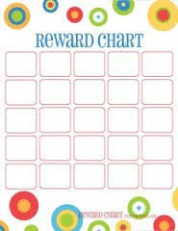 | Use a reward chart to motivate your child
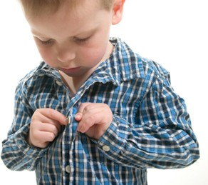 | Ask your child to look at what they are doing.

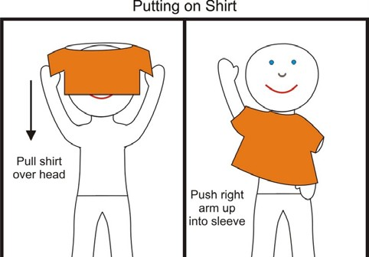 | Talk to your child when dressing.  - Explain what to do step by step.  - Show your child what to do.  - Use hand over hand techniques.  - Use pictures.
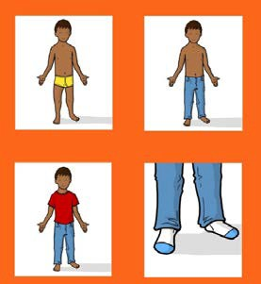 | Step by step:  Break each dressing task down into many small achievable steps.
Do each step the same way every time.
- This way your child knows what is going to happen.
and
- Your child knows what they need to do.

Sitting comfortably: | Make sure that your child is comfortable.  Your child needs good support in sitting to help with balance.  Use a small chair so that your child can have their feet on the floor.  or  Get your child to sit on the floor with support behind them.
Looking:  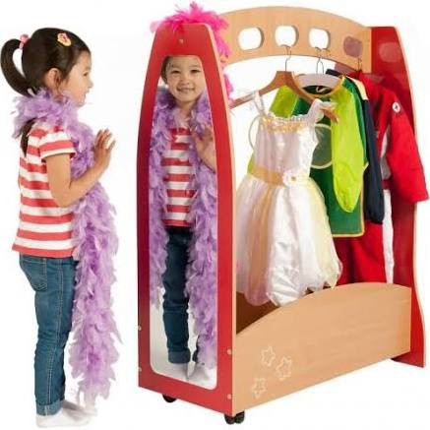 | Try dressing in front of a mirror.  It helps if your child can see what they are doing.
Easy clothes: | Try easy clothes first.  Examples  - Loose fitting clothes  - Clothes without difficult fastenings

Backwards chaining:  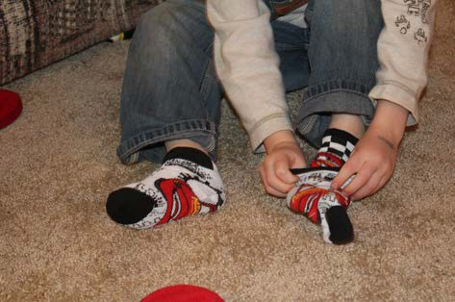 | You start the task and your child finishes.  Example:  -You put a sock over the toes and ankle  -Your child finishes by pulling the sock up.  -This way your child gets the pleasure of completing the task
Orientation: | Show your child that there is affront and a back to clothes.  You can show that there is a picture or pattern at the front.  or  A label at the back.  You can sew a coloured label in clothes to show what is the back.

Easy fastenings:  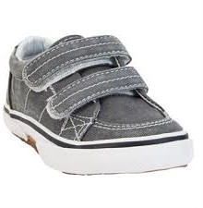  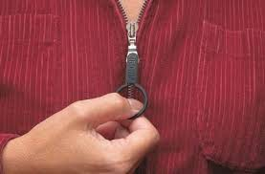 | Choose shoes with Velcro closures.  Add Velcro to button backs.  Add a key-ring or ribbon to zips.  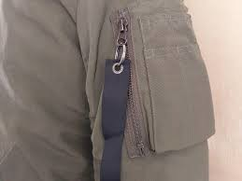
Organising clothes:  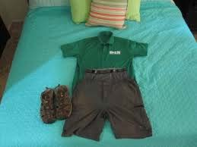 | Organise clothing the night before.  Lay the clothing out in the right order.  Ask your child to help putting their clothes away. This way they know  where it belongs.

Contact details:
Children’s Occupational Therapy
E-mail: epunft.OTenquiries@nhs.net

