

What is carpometacarpal thumb joint osteoarthritis?

It is a common form of arthritis which can affect the joint at the base of the thumb. This joint is known as the Carpometacarpal joint.

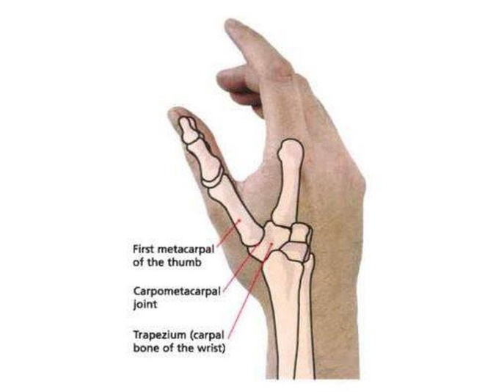

https://www.tekportal.net/carpometacarpal-joint/

**How is it caused?**

It can develop gradually overtime or after using the thumb for activities that are more demanding more than normal in a short space of time.

There are a number of risk factors that increase the risk of developing osteoarthritis including:

* Being female over the age of 40
* Previous trauma or surgery to the affected joint.

**What are the symptoms?**

* Pain at the base of the thumb made worse with movement and eased with rest.
* Difficulty gripping
* Stiffness after long periods of rest
* Swelling at the base of the thumb
* In more severe cases deformity of the joint with bony spurs.

**How is it diagnosed?**

Diagnosis is generally made clinically following a history taking and physical examination. An X-ray may be requested to assess the joint prior to further treatment.

**What can I do?**

Exercise:

Exercise can help to ease pain and improve function. Gentle exercises (see below) can be trialled whilst keeping pain at an acceptable level. If pain builds up to much, try less repetitions and check your technique.



Medication:

Over-the-counter analgesia, such as paracetamol or anti inflammatories such as ibuprofen may also help to reduce your symptoms. If you require further information on pain relief, speak to your GP or pharmacist.

Joint protection:

Consider adjusting the way you use your thumb during painful activities to reduce stress on the joint. For example, spreading load over several joints and using stronger joints rather than just putting strain through the thumb.

Assistive devices:

Devices such as jar twisters, wide grip cutlery, pen grips and key/tap turners can help to reduce the strain on the thumb joint making daily activities more manageable. Visit <https://www.independentliving.co.uk/> for further information.

Splints:

Can help to reduce the strain on the thumb joint during daily activities which you find painful. Ask your therapist for more information about splints that may be appropriate for you.

**Factors influencing pain and recovery**

During your recovery a number of other factors can influence your pain levels. Keep the following factors in mind to help move the healing process along:

Look after yourself

Pain is not usually simply a physical problem. Your general well-being can make you vulnerable to pain and your wellbeing can also be made worse by pain. Looking after your general health and well-being will help recovery. There is helpful advice on this website: [https://www.nhs.uk/oneyou](https://www.nhs.uk/oneyou/)

Reduce stress and anxiety

It is normal for people with pain to have stress, anxiety and change in mood. This may affect your ability to cope with the pain and may influence your pain levels. Help is available if you are being affected by stress, anxiety or low mood – see the links below or discuss with your practitioner.

It is important that your whole nervous system is in a healthy state to aid recovery. If your brain is stressed or overworked this may slow recovery. Relaxation is an important part of your recovery. Simple relaxation techniques may help manage pain and stress. Try to set aside some time each day to relax – you can use relaxation techniques as linked below, or simply an activity you enjoy – reading, deep breathing, sitting in the garden, singing – whatever relaxes you.

Find help and support here: <https://www.nhs.uk/oneyou/every-mind-matters/>

<https://www.northessexiapt.nhs.uk/west-essex>

Physical Activity

Exercise improves fitness, confidence with movement and strength. It can also help reduce your stress and tension and improve your mood and quality of sleep, helping support you to return to normal activities. Perhaps you could simply start by trying to walk for 10 minutes per day.

Alcohol

Avoid alcohol in the early stages of healing (first three days). Evidence has shown this can slow down recovery and increase the chances of re-injury. <https://www.drinkaware.co.uk/>

Sleep

Sleep is very important for your wellbeing. Poor sleep quality, and lack of sleep can make managing pain more difficult. Consistently getting 6-9 hours is recommended. Get help and tips here:

<https://www.nhs.uk/live-well/sleep-and-tiredness/>

Smoking

Smoking can also impact how quickly tissues can heal and affect pain levels. For help with stopping smoking <https://www.essexlifestyleservice.org.uk/stop-smoking/> <https://www.nhs.uk/better-health/quit-smoking/>

**How long will it last?**

If you require 1:1 physiotherapy treatment please fill out a self-referral form which can found at <https://eput.nhs.uk/our-services/essex/west-essex-community-health-services/adults/rehabilitation/musculo-skeletal-physiotherapy> and send to [epunft.mskphysio@nhs.net](mailto:epunft.mskphysio@nhs.net)

If your symptoms have worsened despite the advice given we would recommended you see a healthcare professional for review.

**What other options are there?**

Surgery

If you symptoms cannot be managed Common surgical procedures include include removal of arthritic bone, replacement of the joint (arthoplasty), or fusion of the bone. Common surgical procedures include include removal of arthritic bone, replacement of the joint (arthoplasty), or fusion of the bone.