**How to manage an asthma attack in children**

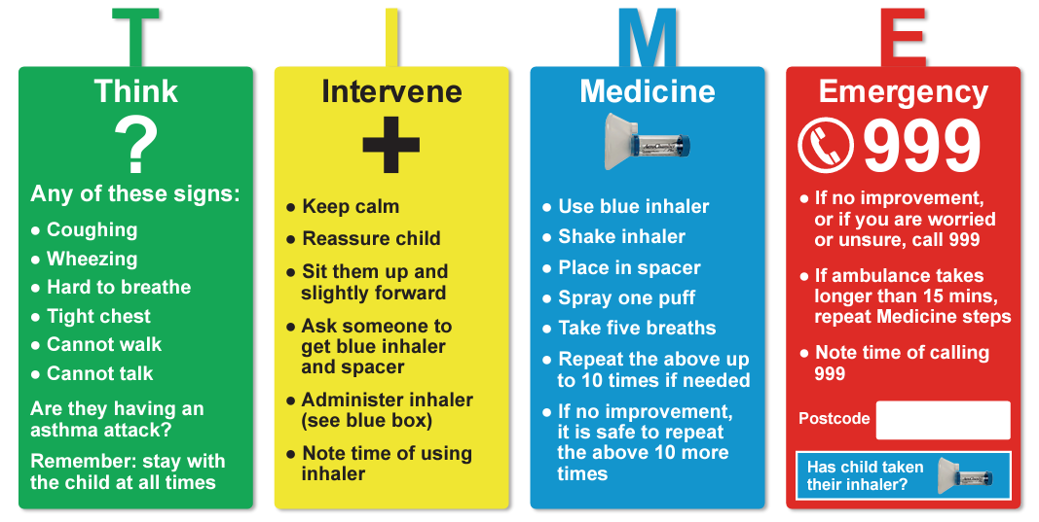

**When asthma strikes, it’s TIME to act**