Children’s Therapy Services Patient Information Learning to use scissors

Choose your hand  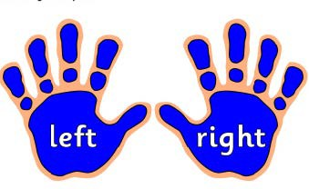 | Hold the scissors in your best hand.  Hold the paper or card in your other hand.
Supportive sitting  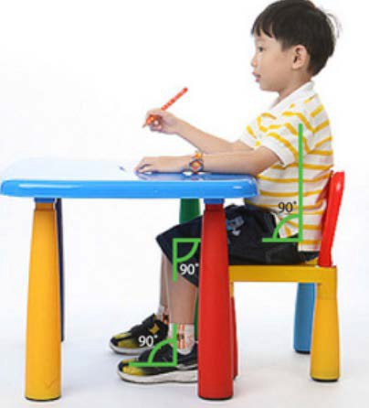 | - Sit at a table  - Sit on a supportive chair

Which scissors?  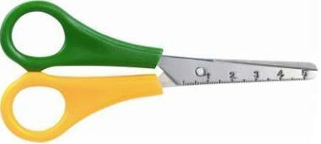 | A lot of scissors are for people who are right handed.  If your left hand is your best hand:  - use left handed scissors
Different scissors  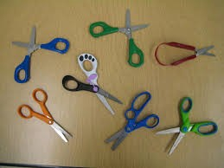 | There are a lot of different scissors.  Ask your child’s teacher or OT which scissors are best for your child.
Which fingers where?  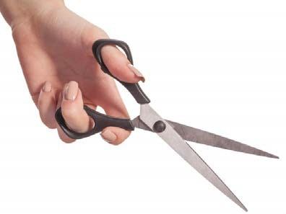 | Thumb goes in top loop.  Middle finger goes in bottom loop.  Pointer finger wraps around the outside of bottom loop.  This helps to keep the scissors steady.

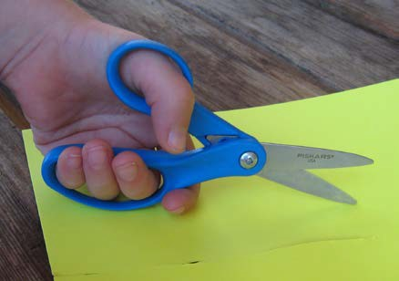 | Other scissors have a small loop and a larger loop.  Thumb goes in small loop.  Middle fingers go in the larger loop.  Make sure your thumb is up When cutting!
Getting strong hands for cutting
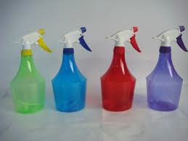  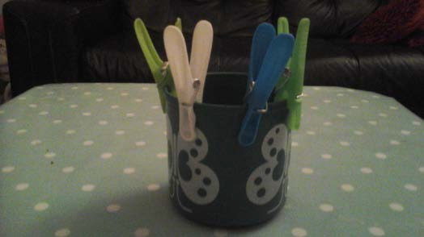 | Opening and closing  To use scissors you need to be good at opening and closing your hands.  Things to try:  Using spray bottles.  Putting pegs on pots

Ripping Paper  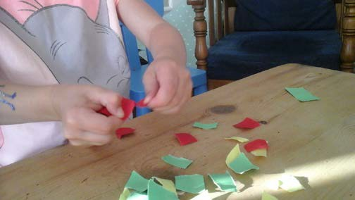 | Step 1  You need to have strong fingers to use scissors.  To get strong fingers try:  - Ripping sturdy paper such as construction paper.  Ripping also helps your child to use 2 hands at the same time.  Cut sturdy paper into strips. Ask your child to rip away.  When they can do this- try larger pieces of paper.
Snipping with Scissors:  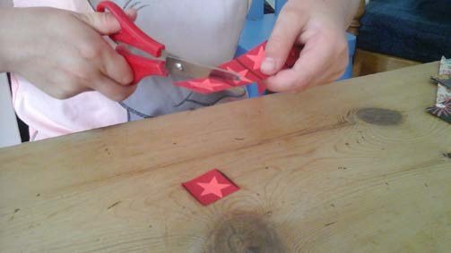 | Step 2  Snipping helps to get strong muscles in your hand.  Snipping is good for learning to open and close the scissors.

Cut a Fringe  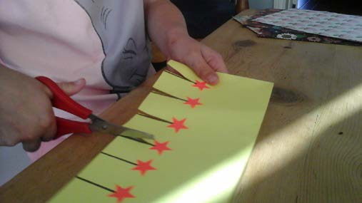 | Step 3  Your child will learn to control the scissors.  Use a ruler to draw spaced lines on paper.  Place stickers at the top of each line.  Ask your child to fringe the paper.  They need to cut on the lines and stop at the stickers.
Cutting Straight Lines  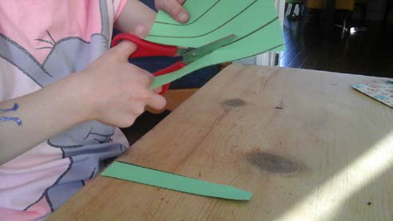 | When your child can do step 1,2 and 3  Step 4  Cut straight lines:  For this you need to be able to open and close the scissors a few times per cut.  This is harder than snipping or cutting a fringe.  Your child may complain of tired hands.  This means that they need more practice to get stronger!

Cutting Zig Zag Lines  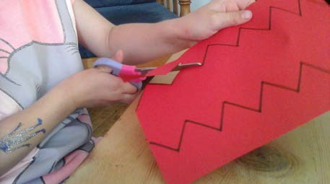 | Zig zag lines are more difficult.  Your child has to turn the paper as they cut.  Your child may get tired hands quickly.  Make sure your child is really ready before doing zig zag lines!
Cutting circles  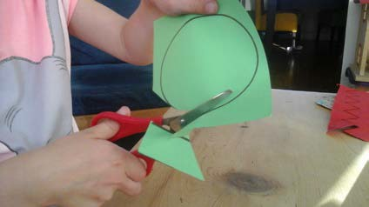  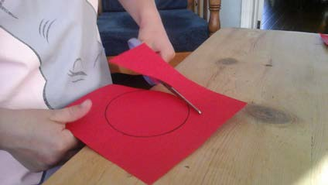  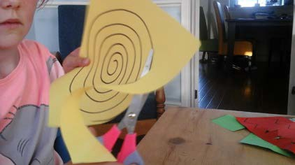 | Right-handed children: cut clockwise.  Left- handed children: cut counter clockwise.  This lets them use the wrist well.  You can draw a face on a big circle.  Your child makes the face stand on his head by turning the circle. He will turn back upright when you keep cutting!  Longer spirals are the next step!

Cutting Right Angles  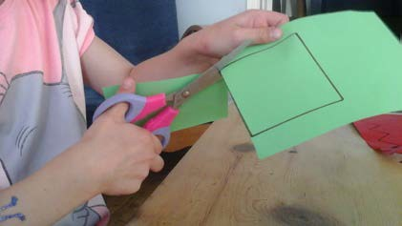 | Cutting squares and rectangles is difficult.  Your child will have to keep turning the paper.  Sometimes your child will turn their arms instead.  Show your child how to hold the paper.  Turn the paper as you cut.  It will take lots of practice before your child masters cutting curved and right angles.
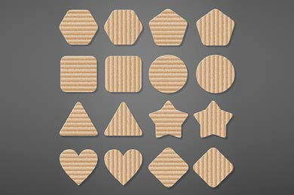 | When you get better at using scissors:  Do more difficult shapes.
Which paper?  Cereal box | Some paper is easier to cut. Start with thin card board  Example cereal box.  This is easier to hold than paper.
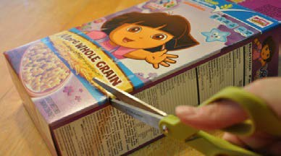

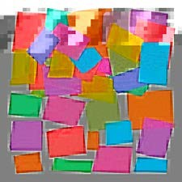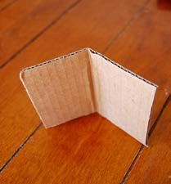  Tissue paper Thicker card | Next : Normal paper  Next: Tissue paper  Next: Thicker card
Cutting out pictures:  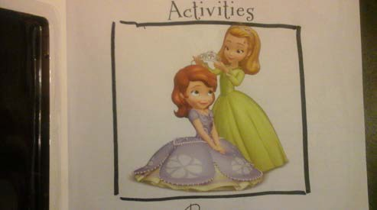 | If you want to cut out a picture:  Draw a border around it and cut it out.
Having fun cutting!  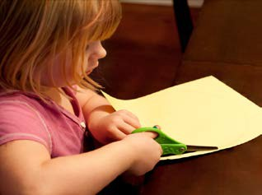 | Important:  You need to practice a lot.  Use scissors at school and at home.

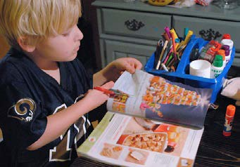  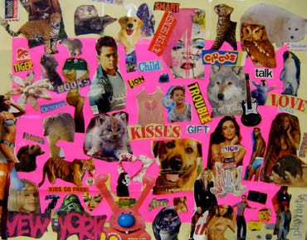 | Example:  Cut out pictures from magazines.  Cut out pictures printed from websites.  Make posters of your favourite things.

Contact details:
Children’s Occupational Therapy
E-mail: epunft.OTenquiries@nhs.net

