Children’s Therapy Services

Patient Information
Learning to use knife and fork

 | Things to try
Posture:  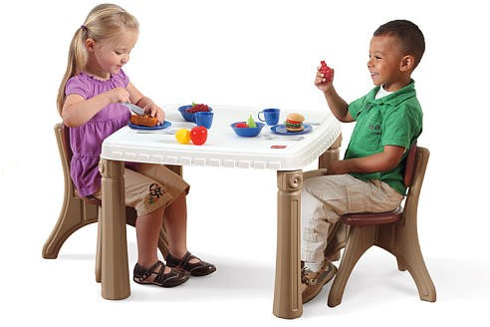  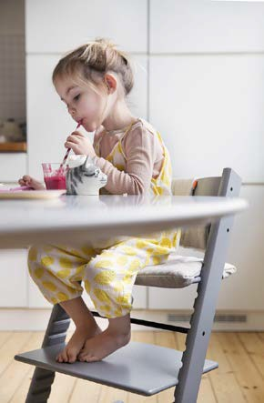 | Make sure your child’s chair is at a good height for the table they are sitting at.  -Your child’s feet need to be supported.  -Your child’s elbows need to rest comfortably. This makes it easier to use their hands.  Think of the best place for your child to sit at the table.  It should be calm so that your child can concentrate. Do not put them in front of the television or facing their toys.

Practice using a knife  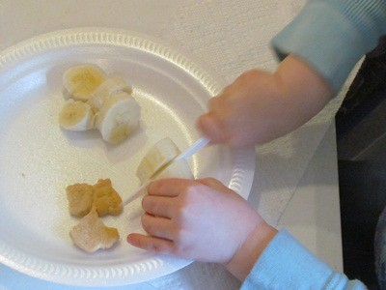  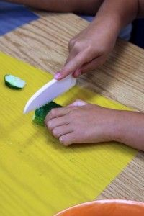  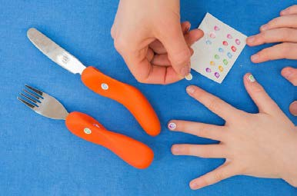 | Step 1:  Start with using the knife on its own.  First cut up soft foods. Examples:  - Banana  - Boiled carrots  - Canned fruit  - Sausage  Cut by moving the knife backward and forwards. You can also use play- dough to practice.  The pointer finger of the hand holding the knife should be straight when cutting  Put a sticker or dot on the knife and fork.  This helps your child to know where their fingers need to go.

Practice using a fork  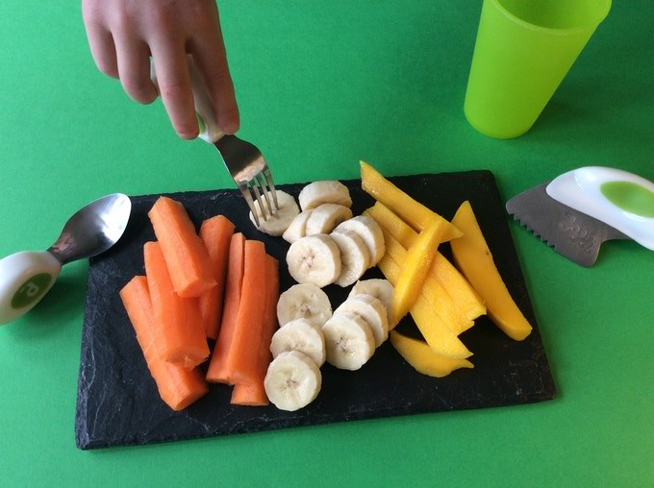  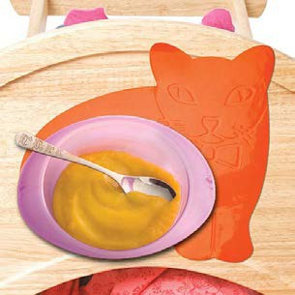  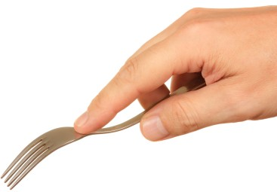 | When your child can use a knife properly:  Step 2:  Use a fork on its own to stab food.  Start with stabbing soft foods:  - Cooked carrot slices  - Bread  - Soft fruits  - Sausage  - Cucumber  - Cheese cubes  Use a plate with an edge This stops the food slipping of the plate  Put a damp cloth or a non- slip mat under the plate This stops it from slipping  The pointer finger of the hand in which your child holds the fork has to be straight when stabbing.

Practice using knife and fork  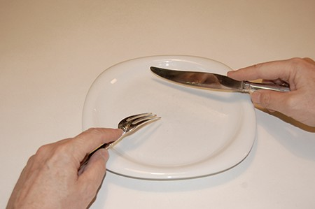 | When your child can do step 1 and step 2  Step 3:  Using a knife and fork together:  -stab first using the fork  -then to cut using the knife (backwards and forward)
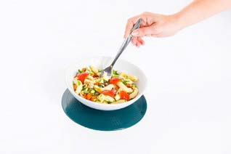  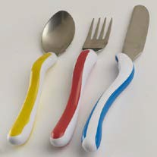  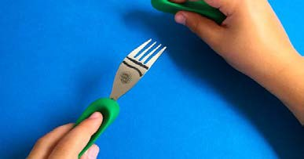 | Equipment  - Non-slip mats help to stabilise the plate to stop it moving.  - Use junior caring cutlery  or  - adult caring cutlery  Caring cutlery has wider shafts and is easier to hold

Contact details:
Children’s Occupational Therapy
E-mail: epunft.OTenquiries@nhs.net

